

FACULTY OF TECHNOLOGY AND ENGINEERING
DEVANG PATEL INSTITUTE OF ADVANCED TECHNOLOGY AND RESEARCH

DEPARTMENT OF INFORMATION TECHNOLOGY

A.Y 2026-27 Semester-3

LAB MANUAL

CSUC201: Fundamentals of Data Structure and Algorithms



Practical 4
Practical AIM:
To implement core singly linked list operations and develop the ability to manipulate dynamic sequences through real-world problem scenarios.
Practical 4.1
Problem Definition:
A hospital manages a queue of patient tokens. New critical patients must be added to the front, routine patients are added to the end, and occasionally a patient with a priority number must be inserted at a specific position in the queue. Given a sequence of such operations, implement all three insertion types and print the final queue after each operation.
Describe how your insertion at a specific position works. What does your solution do if the position given is greater than the current length of the queue? Is that handled explicitly or does it cause an error?
Problem faced:
I faced difficulty while inserting a node at a specific position because the links were not connected correctly.
Solution:
I used a temporary pointer temp to reach the node before the required position. Then I connected the new node using newNode->next = temp->next and temp->next = newNode.
Output:
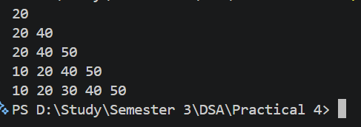
Practical 4.2
Problem Definition:
The hospital also needs to remove a patient token from the queue when a patient leaves, print all remaining tokens from last to first for an end-of-day audit, and display the full queue from front to back at any point. Implement deletion by value, reverse printing, and forward traversal on the same queue from Problem 4.1a.
Describe how your reverse printing works. Does it use any extra storage, or does it work purely by following the links? Can you think of another way to reverse-print without modifying the original queue?
Problem faced:
I faced difficulty while deleting a node by value and printing the linked list in reverse order.
Solution:
For deletion, I used a temp pointer to find the previous node and adjusted the links. For reverse printing, I used recursion to reach the last node and printed the values while returning.
Output:
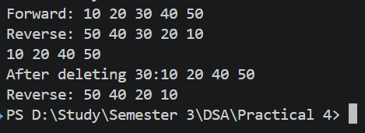

Key Questions
1. [Problem 1] Inserting at a position beyond the current length of the list is an invalid operation. Should your solution silently insert at the end, report an error, or do something else entirely? Justify your choice and explain what assumption about the caller your choice makes.
ANS:
Inserting beyond the current length should report an error rather than silently inserting at the end. This helps detect invalid input and prevents unexpected changes to the list. The caller is assumed to provide a valid position within the current list range. For example, if the length is 5, inserting at position 7 should be rejected.
2. [Problem 2] If the node to be deleted is the only node in the list, how many pointers need to change and what must they be set to? How is this case structurally different from deleting a node in the middle?
ANS:
If the node to be deleted is the only node, only the head pointer needs to change. It must be set to NULL, making the list empty. No other node's pointer needs to be modified because there is no previous or next node. In contrast, deleting a middle node requires changing the previous node's next pointer to skip the deleted node.
Github Link:
https://github.com/dhanvi-219/FDSA/tree/main/Practical%204

